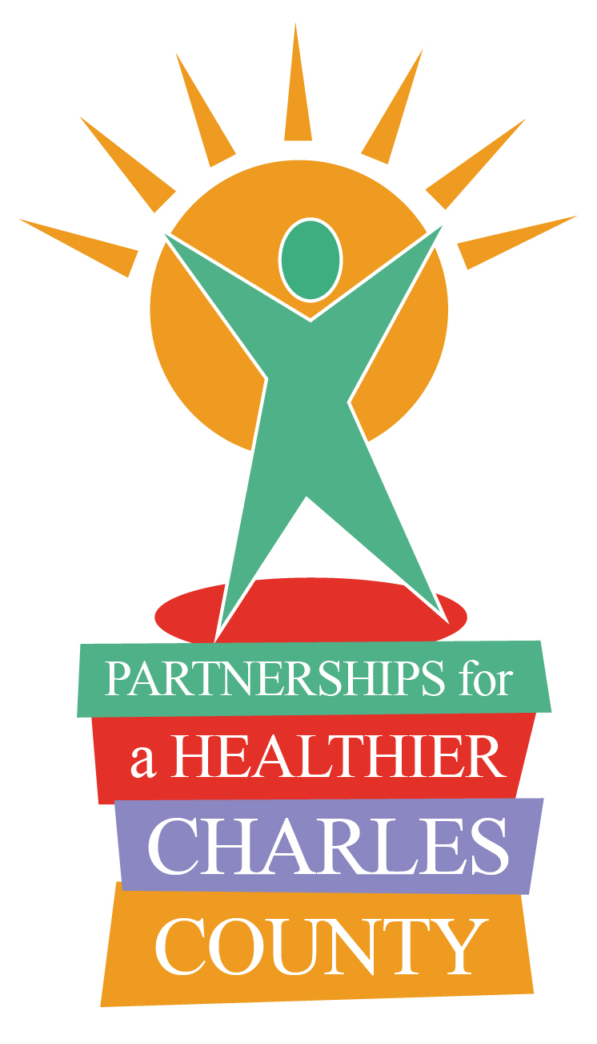
Partnerships for a Healthier Charles County

P.O. Box 1050
White Plains, MD 20695-1050
(301) 609-6901

Meeting Agenda
September 16, 2020

1. Occupational Therapy Hand Therapy Program and Joint Protection Strategies. Courtney Potter, Occupational Therapist. University of Maryland Charles Regional Rehabilitation.

2. Statewide Initiatives toward the Maryland Diabetes Action Plan. Lisa Ellis Marr, Program Manager, Maryland Department of Health. Center for Population Health Initiatives.

3. Charles County Initiatives to Address Diabetes. Angela Deal, Community Health Educator, Charles County Department of Health.

4. Charles County Community Health Needs Assessment Update. Amber Starn, Epidemiologist, Charles County Department of Health.

Remaining 2020 Meeting Date:
December 9th

